CS585
Database Systems
Midterm Exam

Name: _____________________
Student ID: _________________

 | Maximum | Received
Problem 1 | 10
Problem 2 | 12
Problem 3 | 12
Problem 4 | 12
Problem 5 | 15
Problem 6 | 12
Problem 7 | 12
Problem 8 | 15

2 hr exam. Closed book. One single sided 8.5 X 11 sheet of notes allowed.

- 10 pts
Indicate whether each of the following statements is true or false (T/F):

______One can assure that a point-region quad tree for a fixed set of points is
always balanced by inserting points into the tree in the optimal order.

______During searching an object in R-tree, one might need to search the entire
database.

______A relationship is an association among two or more attributes.

______One owner entity is associated with one or more weak entities, but each weak
entity has a single owner.

______If we compare two null values using <, >, =, and so on, the result is always true.

______Metric relationships are a subset of topological relationships in Rose
algebra.

______One of the limitations in object oriented databases is that they cannot
handle complex object models.

______In an object relational database, an object table is a table in which all
columns of the table are of object types.

- 12 pts
Reduce the given EER diagram to relations using pure relational model (i.e., No Object Oriented or Object Relational). Be sure to identify all primary and foreign keys.
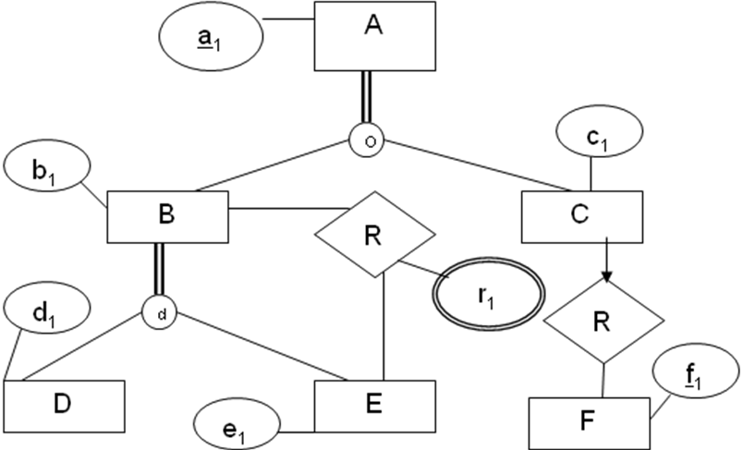

- 12 pts
A university database contains information about professors (identified by social security number, or SSN) and courses (identified by courseId). Professors teach courses; each of the following situations concerns the Teaches relationship set. For each situation, draw an ER diagram that describes it (assuming no further constraints hold).
  - Professors can teach the same course in several semesters, and only the most recent such offering needs to be recorded. (Assume this condition applies in all subsequent questions.

  - Every professor must teach some course.

  - Every professor teaches exactly one course (no more, no less).

  - Every professor teaches exactly one course (no more, no less), and every course must be taught by some professor.

- 12 pts

The following questions are based on the following relational schema:
Emp (eid: integer, ename: string, age: integer, salary: real)
Works (eid: integer, did: integer)
Dept (did: integer, dname:, managerid: integer)

Write SQL to create tables for Emp, Works, Dept such that Works have two foreign keys
referring to Emp (eid) and Dept (did) respectively, and Dept has a foreign key (managerid)
referring to Emp respectively. In addition, when a Dept tuple is deleted, all Works tuples
referring to it should be deleted. When an Emp tuple is deleted, for all Dept tuples referring to it, the managerid should be set to null. Note eid is primary key for Emp, and eid and did together are primary key for Works. And did is the primary key for Dept.

- 15 pts

Consider the relational conceptual database schema below for keeping track of course registration of students:

COURSES (Code, Title, Dept)
Registered (Code, SSN)
STUDENTS (SSN, Name, Dept, GPA)

Here, COURSES contains a tuple for each course, recording its code, title, and department providing the course. STUDENTS records the SSN, name, home department, and GPA of the students. REGISTERED keeps the relation between courses and students.

(a) Retrieve the name of each student who registered the course titled “Database Systems”.

(b) Retrieve the title of the course along with the number of students who registered this course in the descending order of registered student number.

(c) Retrieve the name of student(s) who earned the maximum GPA in the
department that provides more than 30 courses.

- 12 pts
Consider the six Tram Stations shown in the following picture of USC campus.

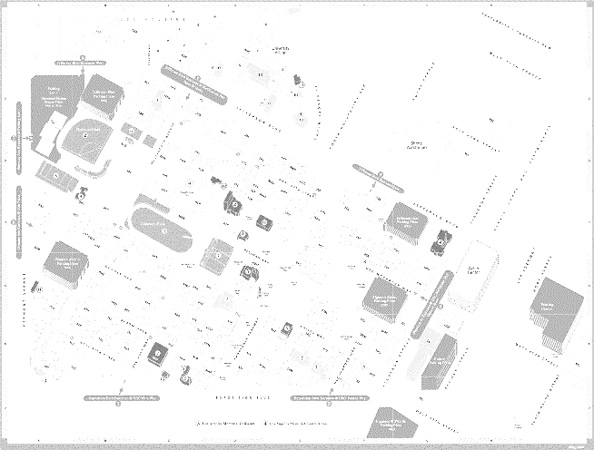
S1
S2
S5
S6
S3
S4

- Build a PR Quadtree for these six points. (You do not need to draw the actual tree, just show the partitioning on the above figure)

- A Tram starts from the first station which is S1 and after passing through all the stations stops at the last one which is S3. Construct a PM1 Quadtree for this path on the figure below.
S1
S2
S5
S6
S3
S4

- 12 pts

A road network is maintained in a spatial database as following:

Road ID | Road Segment
L1 | (4, 7), (6, 8)
L2 | (6,4), (7, 7)
L3 | (2,1), (3, 2)
L4 | (0, 2), (1, 5)
L5 | (3, 3), (5, 6)

Assume that the roads are inserted in to the table with the ascending order of
RoadID (i.e., L1, L2, L3, L4, L5). Also assume that (m,M)=(2,4).

Draw the R-Tree index generated for the above table after each insertion.
In other words, you should draw five R-Trees. Use “Quadratic” method to
split the R-Tree Nodes. You need to briefly describe what happens after each
step. If you need to split a node, you should clearly and completely describe
which line(s) you select to become the first element of each child node, and
then which lines are added to each child node and why. You could use the
following chart to draw the lines.

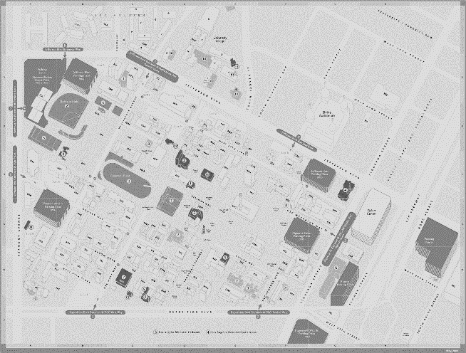
1234567
R1

R2

R4

R5

R3

Additional space for problem 7

- 12 pts
Considering that we have 3 types of databases available to us (Relational, Object Relational, and Object Oriented), Complete each of the following three sentences by providing examples and reasons why.

- A relational database may not be the best choice when…

- An object relational database may not be the best choice when…

- An object oriented database may not be the best choice when…

Additional space

